This guide describes how to connect the various electronics for both the TX1 and TK1 versions of 'Jet' with the differences noted along the way. Soldering is required to connect some of the wiring. If you are not familiar with soldering, please read over the following soldering tutorials:

<https://learn.sparkfun.com/tutorials/how-to-solder---through-hole-soldering> <http://www.ladyada.net/learn/soldering/thm.html>

**Tools**

Soldering iron Solder

Wire cutter Wire stripper

Heat gun for heat shrink Small screwdrivers

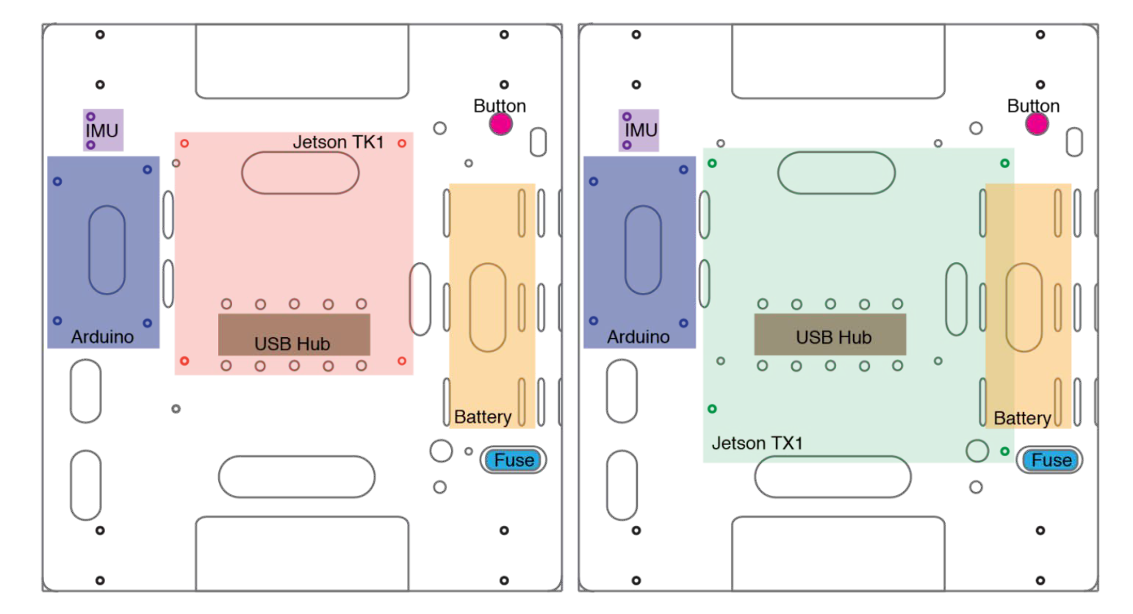**Electronic Mounting Diagrams**

These diagrams show where to mount various electronic components using the mounting holes on the ABS mounting plate for both the TK1 and TX1 versions of Jet.

# Power Switch

This is the main power switch that connects the battery to the Jetson TX1/TK1 and the motors.

1. Attach the power switch to the ABS mounting plate.

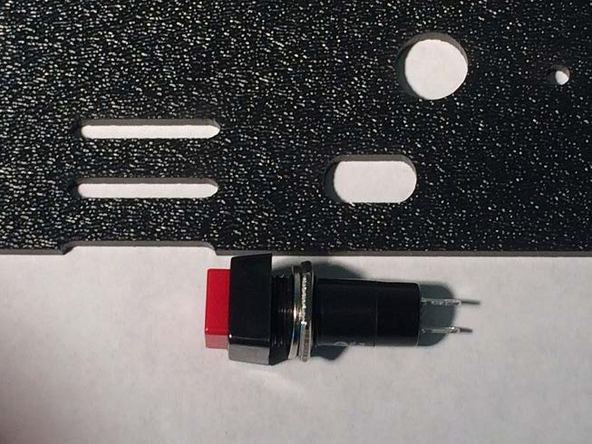

1. 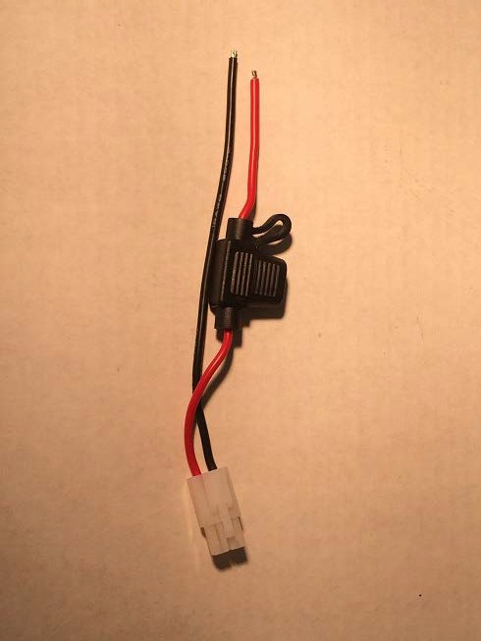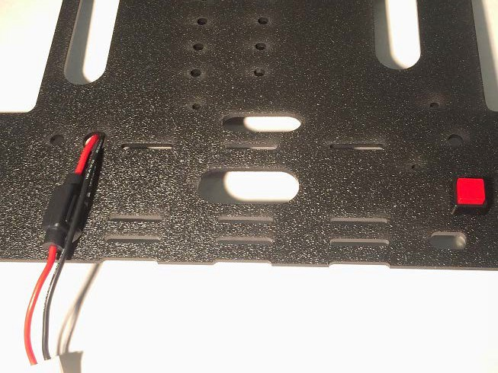Insert the fuse into the appropriate hole in the plate.
2. Run the red/black wire ends into the wire hole.
3. Measure the distance from the end of the red wire to one of the contacts of the power switch.
4. Cut a piece of the red 16AWG stranded wire and solder the ends to the fuse wire and the power switch contact.

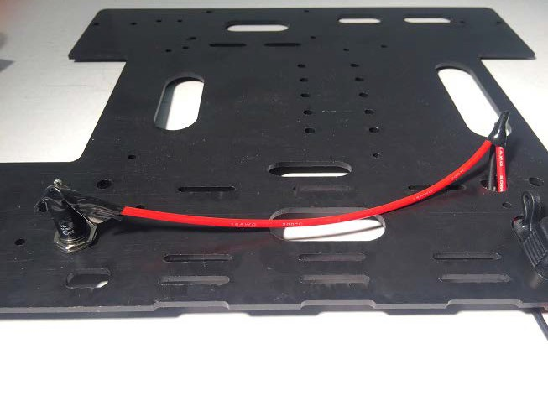

**Mount the Battery and Battery Connector**

The battery used with Jet is a 3S (11.1V) Li-Po battery. These batteries can be dangerous and must be used with an appropriate Li-Po battery charger.

* 1. 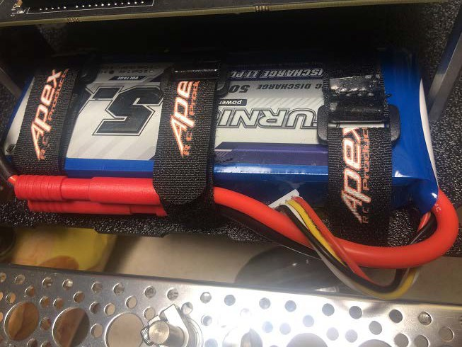Strap on the battery using 3 velcro straps. Use the middle strap to hold down the red HXT battery connector.
  2. The next step is to replace the white plastic Tamiya connector on the fuse with a red HXT connector. Measure the approximate length of the fuse terminal cable and cut off the Tamiya connector.

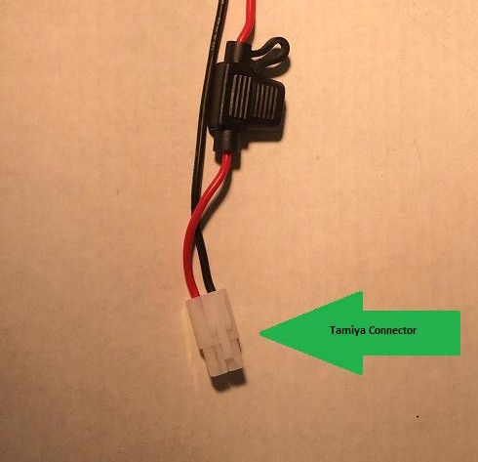

* 1. Solder on the new HXT connector and heat shrink the joints so that no solder joints are exposed.

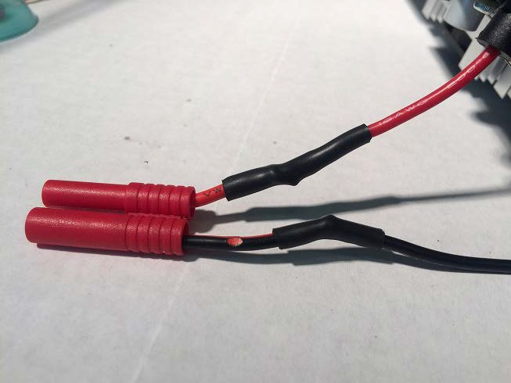

* 1. Check that the new HXT connector fits with the battery connector.

# Mount the USB Hub

The USB hub will be used to connect the Jetson TX1/TK1 with the Arduino Mega and the Logitech camera.

* + 1. 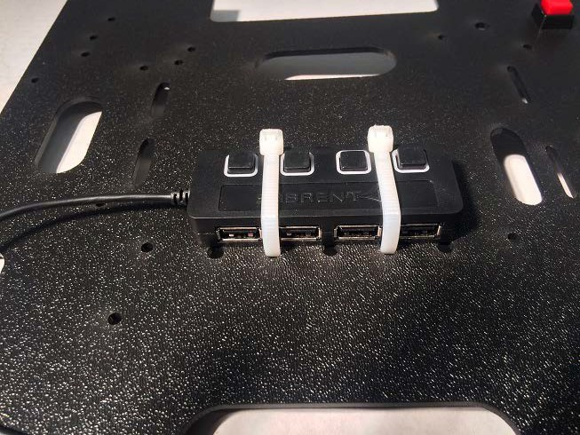Install the USB hub into the appropriate holes and secure the hub using cable ties. The hub will reside underneath the Jetson TX1/TK1.

# Mount the Jetson Board

The Jetson TX1/TK1 will sit above the USB hub. Use 2" standoffs and 6-32 screws for the TX1/TK1. **NOTE**: The TK1 will have a different shape than the TX1 shown here. You will find appropriate mounting holes for it on the mounting plate. Refer to the digram of the mounting plate above.

1. Screw the standoffs to the mounting plate.

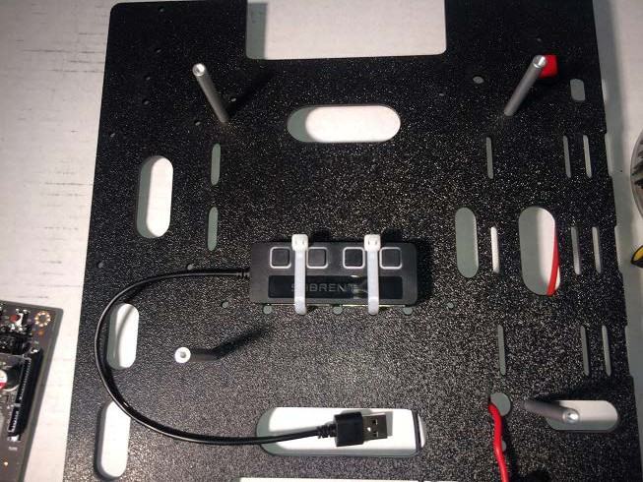

1. 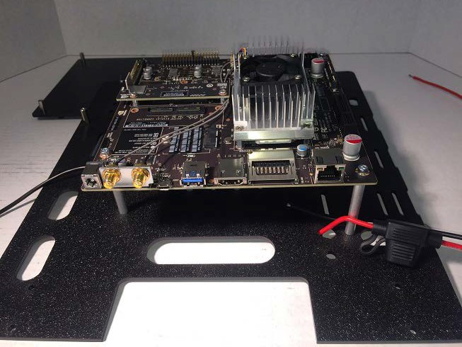Once the spacers are secure, attach the Jetson to the standoffs using 3mm screws.

# Mount the Arduino Mega

The Arduino Mega should be mounted in the same way as the Jetson TX1/TK1. The standoffs for the Arduino Mega are 15mm tall. The screws are 3mm sockethead machine screws 8mm length.

1. 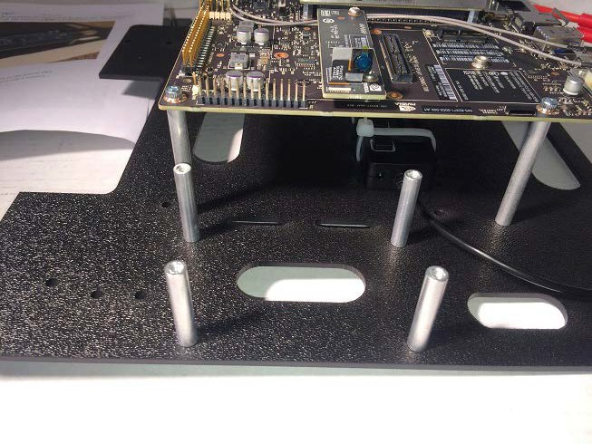Screw the standoffs to the mounting plate.
2. 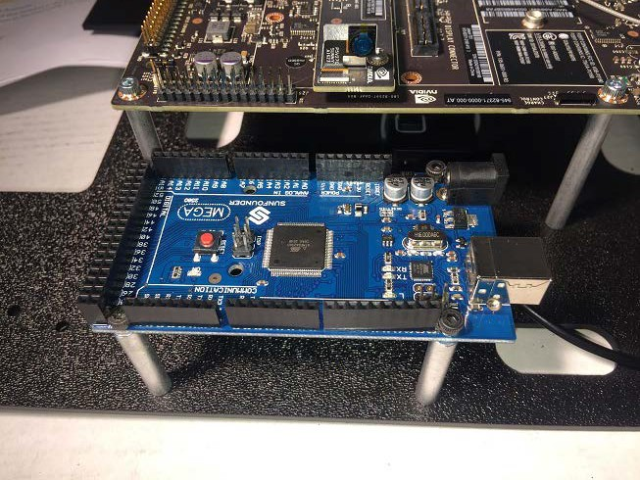Mount the Arduino on the standoffs using the 3mm head/8mm length screws

# Install the Wireless Card and Antenna (TK1 'Jet' only)

The wireless card is a mini-PCIe card that attaches to the Jetson TK1.

* 1. Plug in the wireless card and screw in the card using two screws.

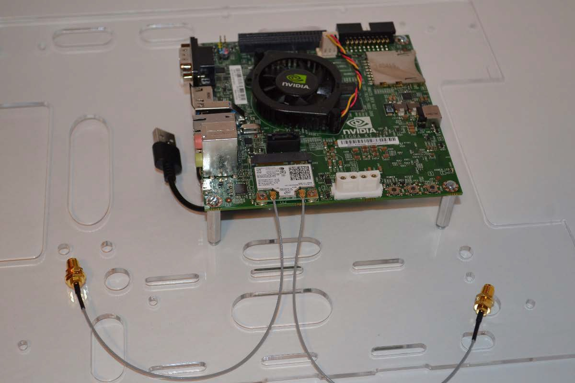

* 1. Connect the two antenna to the wireless card.
  2. 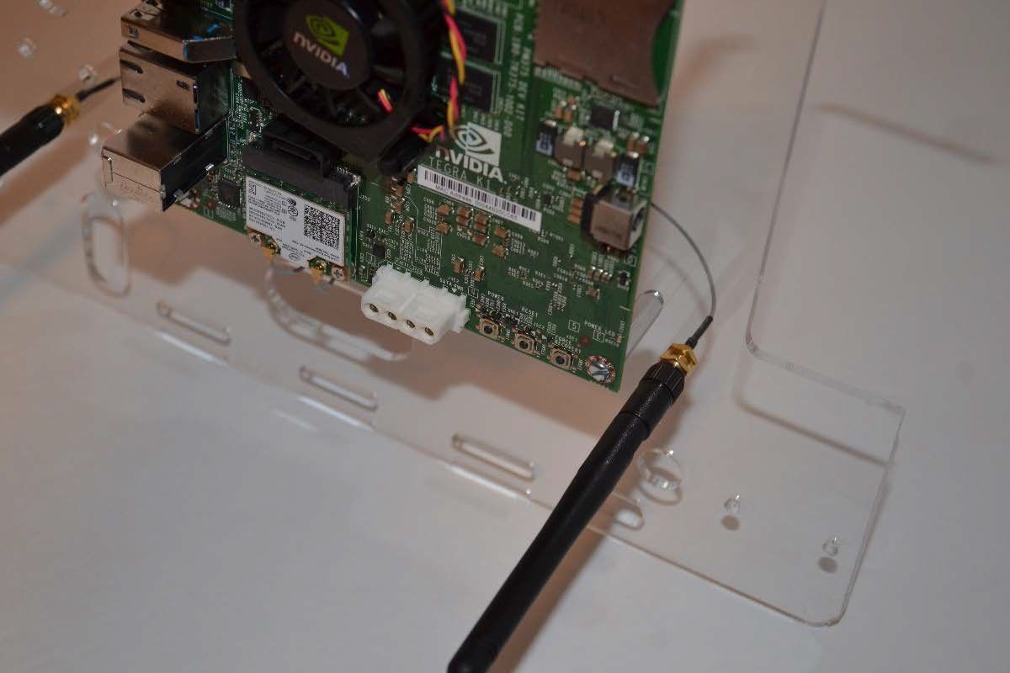Run the antenna wires through the provided hole in the mounting plate and screw in the antenna.

# Soldering the Arduino Daughter Cards

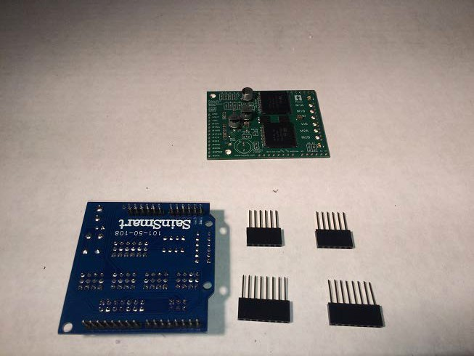The Arduino is supported electrically by two cards: the Sensor Shield and the Pololu motor driver shield.

The Pololu must have data connectors soldered to it in order to connect to the Sensor Shield.

* + 1. 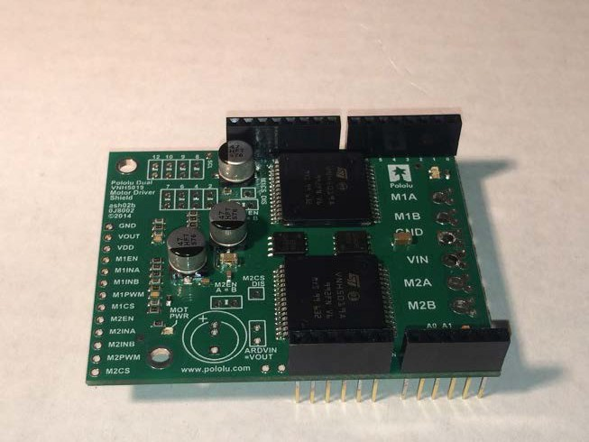Solder two 8-pin and two 6-pin data connectors to the Pololu motor driver shield in the edge mount holes as shown.

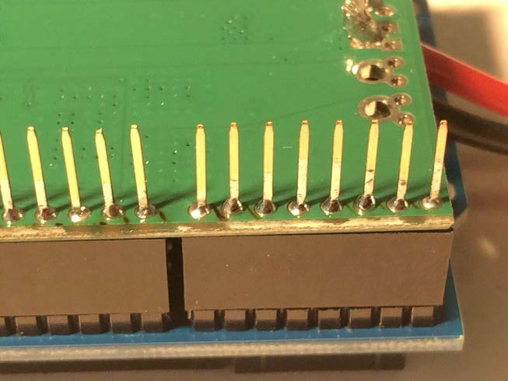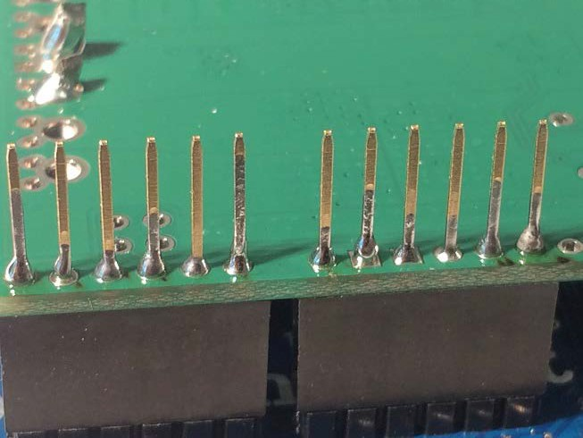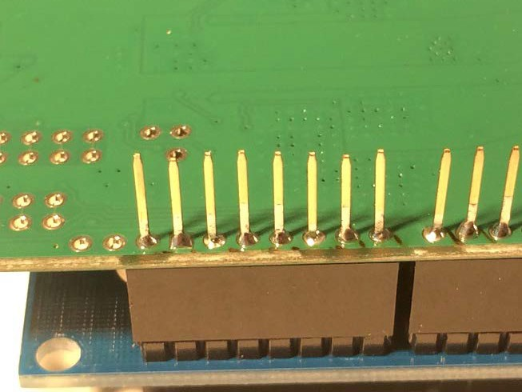

* + 1. 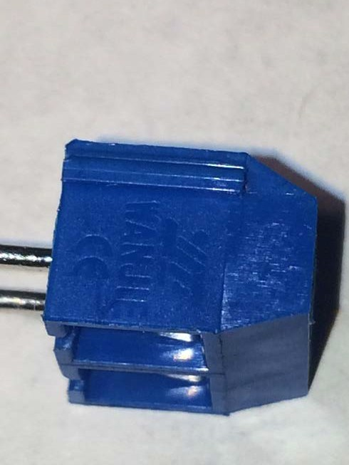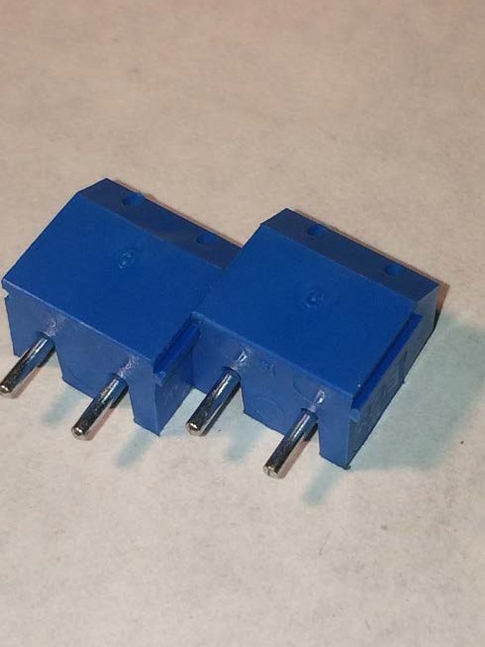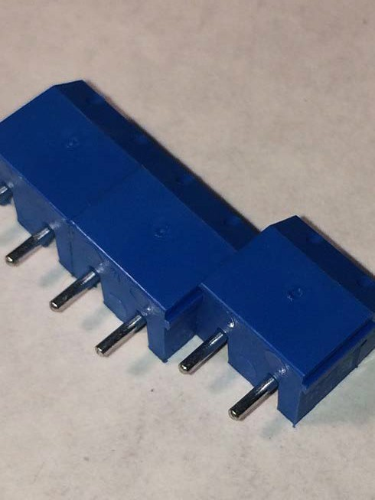Connect three powerblocks together as shown. Each is grooved to fit into the side of the next.
    2. 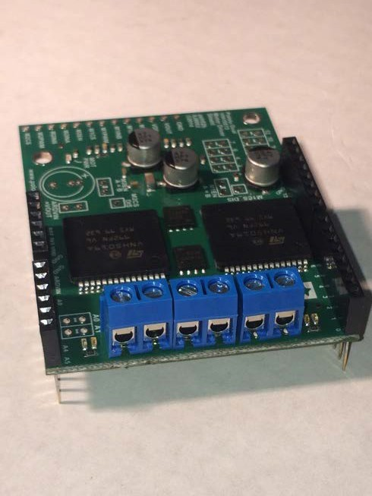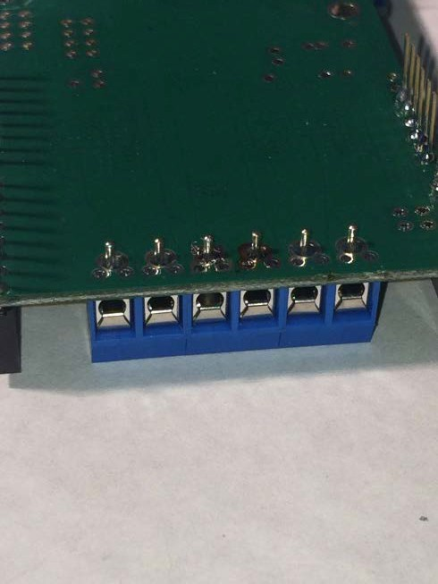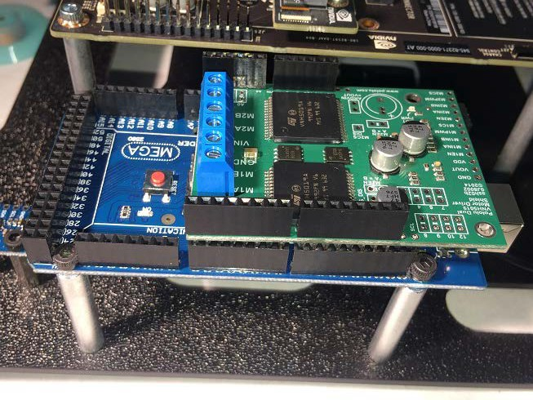Solder the powerblocks into the power mounting holes on the Pololu.
    3. Insert the Pololu into the Arduino data connections as shown, and then insert the Arduino shield into the Pololu data connections **(not shown)**.

# Soldering Power Connections

* + - 1. Measure and cut a piece of black jumper wire from the battery connector black wire to the center of the underside of the mounting plate.
      2. Solder the end to the black jumper wire to the battery connector, leaving the other end free.

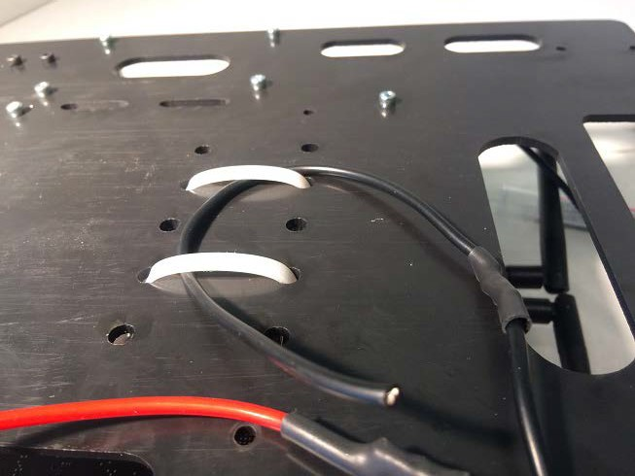

* + - 1. Measure and cut a piece of black jumper wire from the center of the underside of the mounting plate to the power connector on the TX1/TK1.

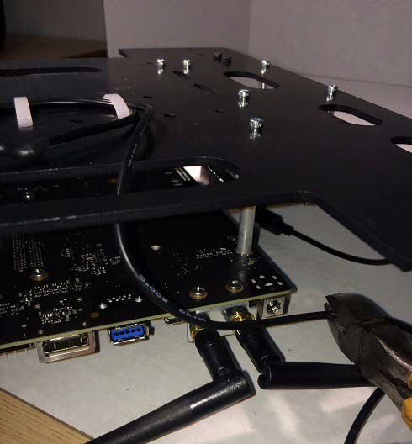

* + - 1. 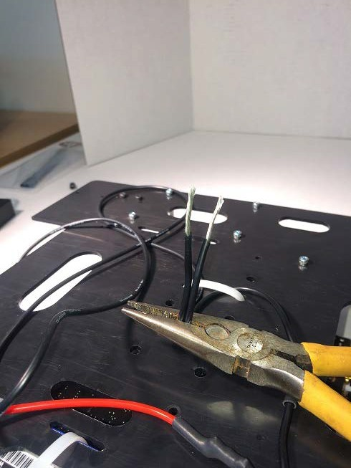Run one stripped end under the zip ties holding the USB hub in place. The other end can remain next to the TX1/TK1 power connector.
      2. 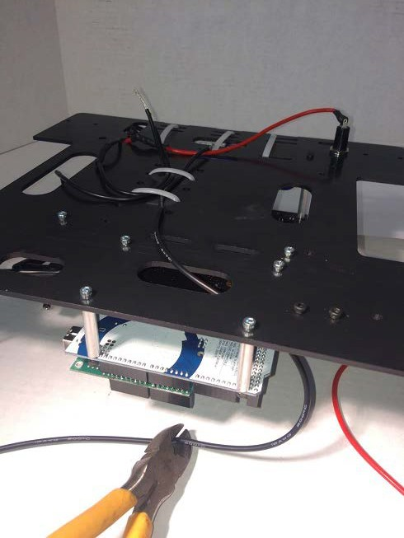Measure and cut a third piece of black jumper wire from the center of the underside of the mounting plate to the terminal blocks on the Pololu motor driver shield.
      3. 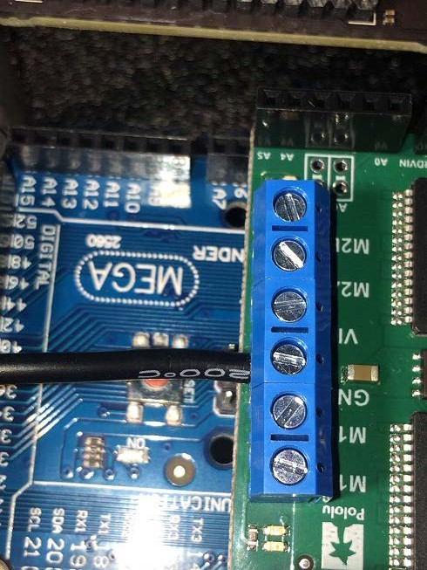Strip and connect the black wire to the Pololu motor driver shield in the terminal block marked "GND".
      4. 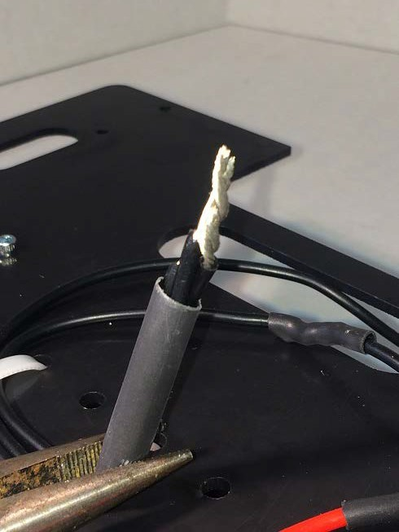Strip the three black power wires at the ends under the chassis and twist them together. Solder the ends and cover in heat shrink.
      5. 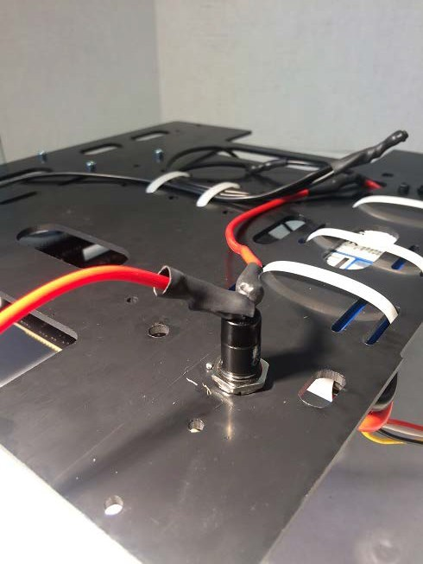Solder the red jumper wire to the open side of the power switch and cover in heat shrink.
      6. 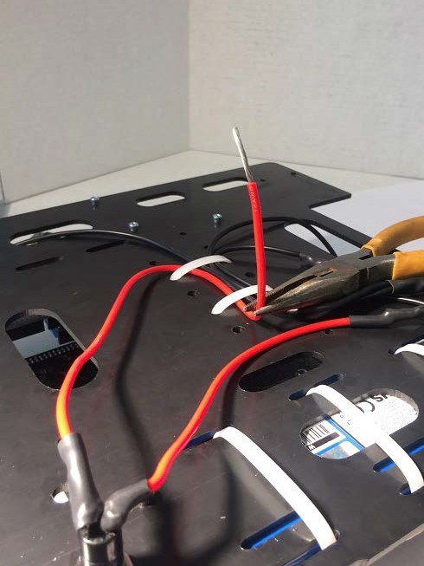Measure and cut the other end so it runs under the zip ties securing the USB hub.
      7. 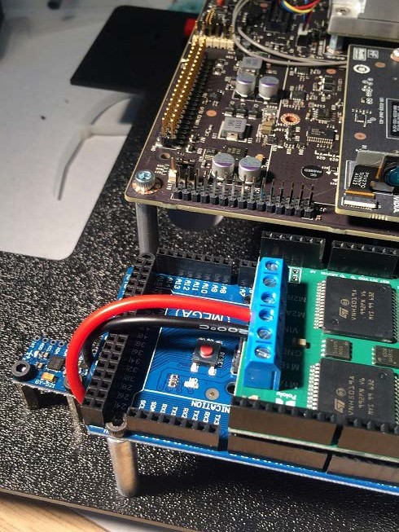Strip and insert the red jumper wire into the Polulu motor driver shield in the terminal block marked "VIN".
      8. 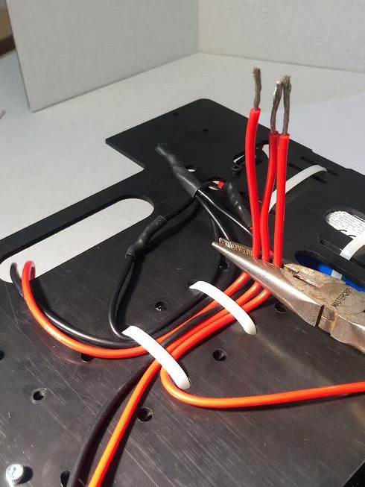Run the other end of the red jumper wire through the mounting plate and under the zip ties securing the USB hub. Strip the end.
      9. 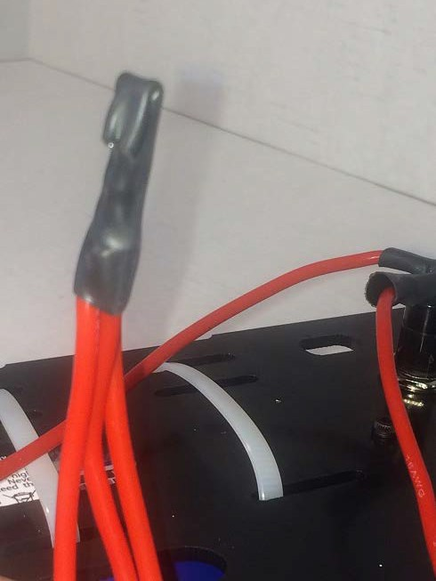Twist the three red power wires together, solder, and cover in heat shrink.
      10. 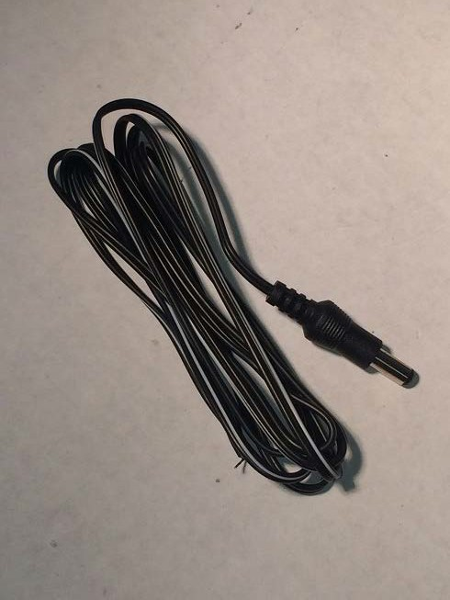Locate the power connector for the TX1/TK1.
      11. 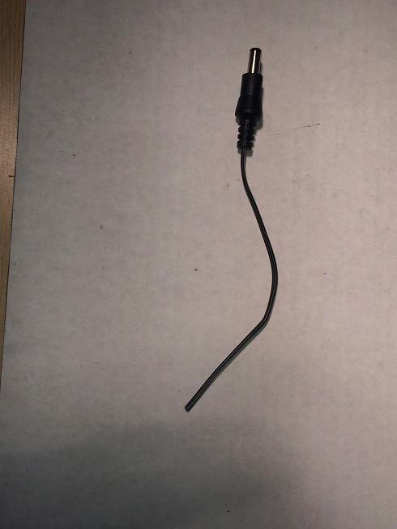Cut the wire for the TX1/TK1 power connector to shorten.
      12. 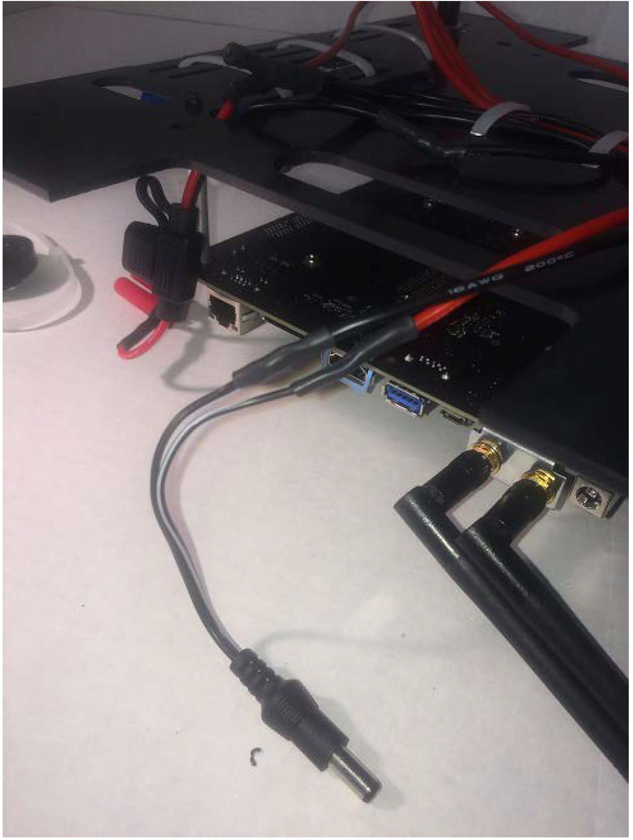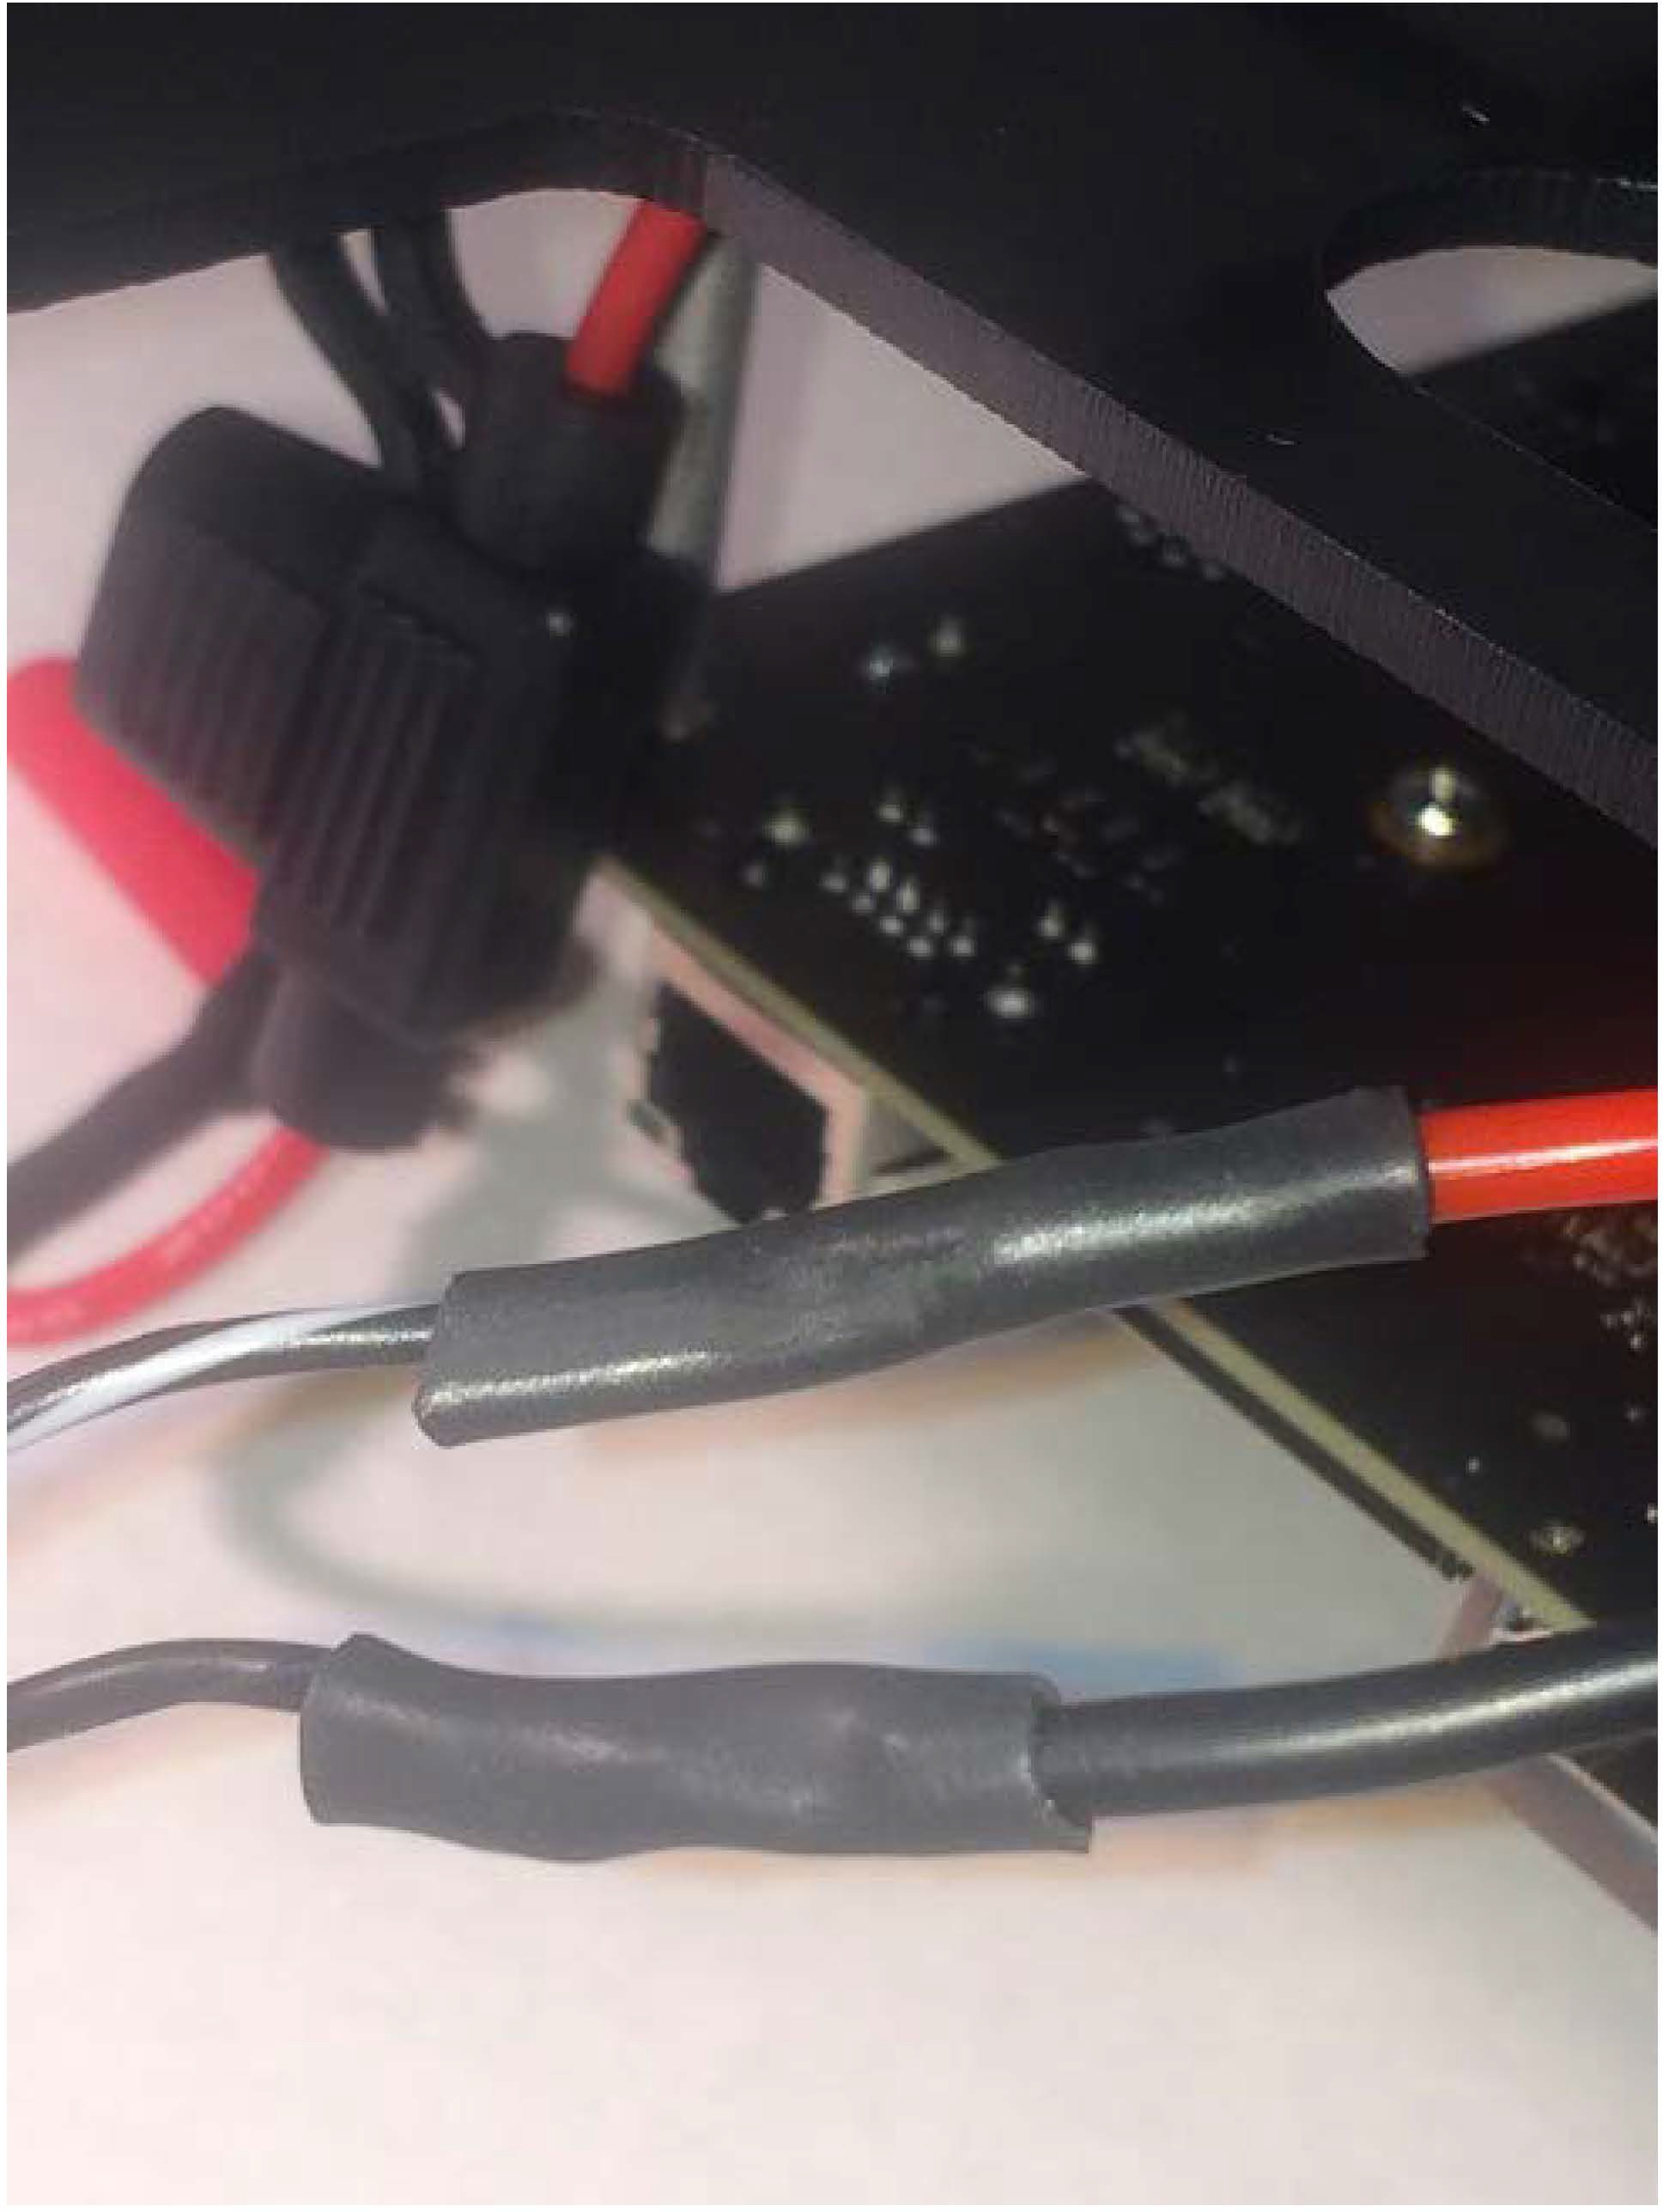Solder the TX1/TK1 power connector wire with the white strip to the red power jumper. Solder the solid black wire to the black jumper. Cover with heat shrink.
      13. 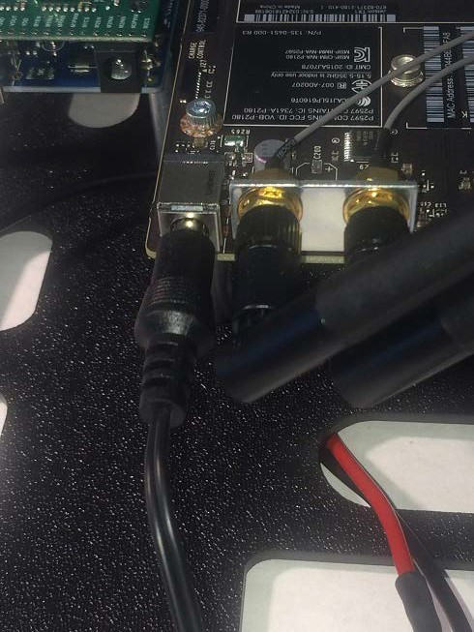Plug the TX1/TK1 power connector into the TX1/TK1.

# Install the MPU

* + - * 1. 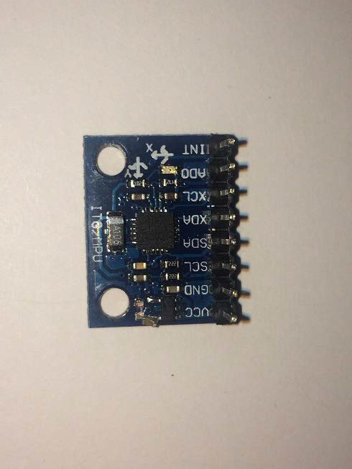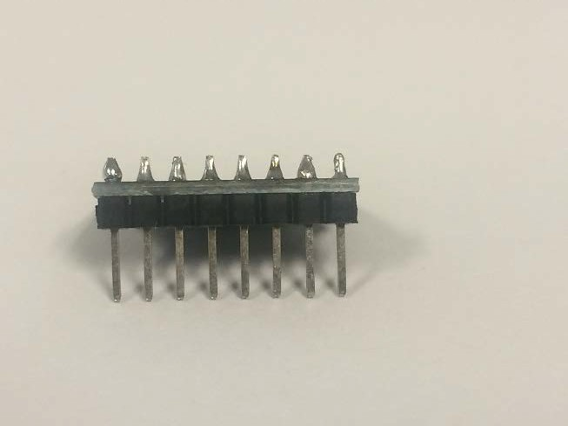Solder an 8-pin connection extender to the MPU output points.
        2. 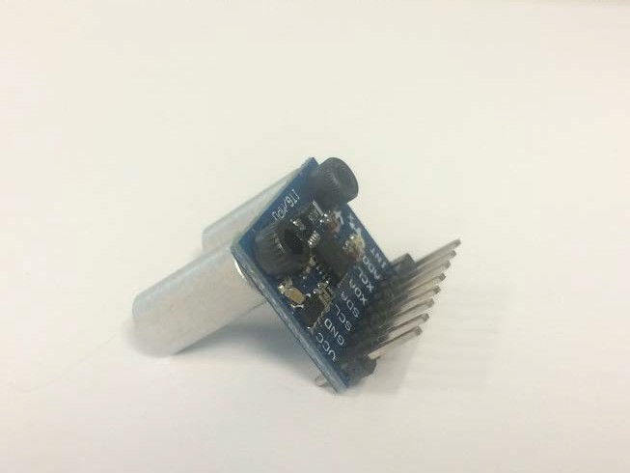Use two 3mm screws to connect the MPU to the 15mm standoffs.
        3. Mount the MPU to the mounting board next to the Arduino using two 3mm screws.

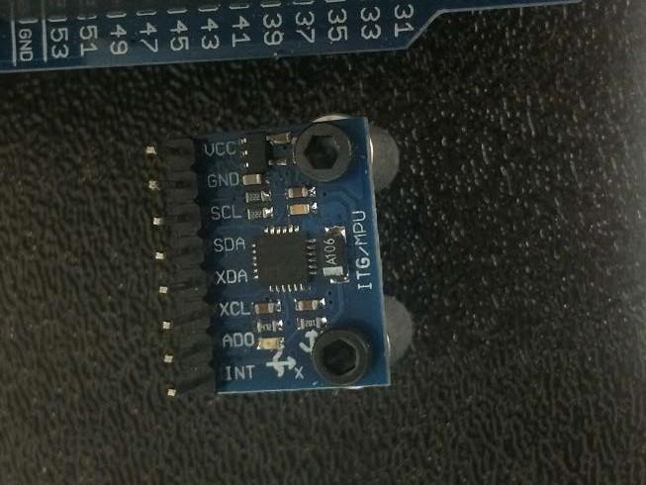

# Install the Sonar Mounts

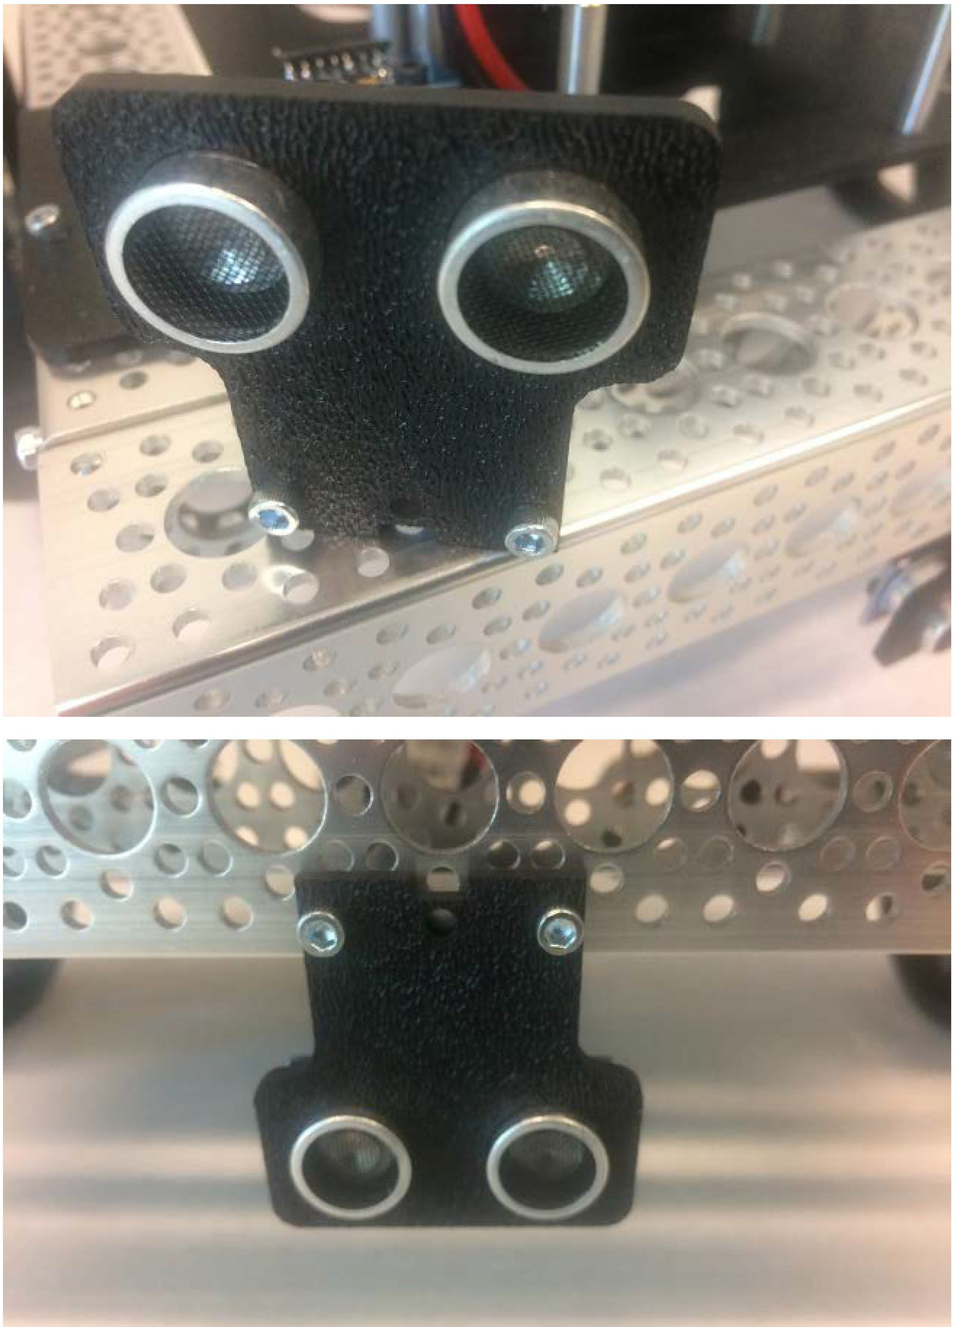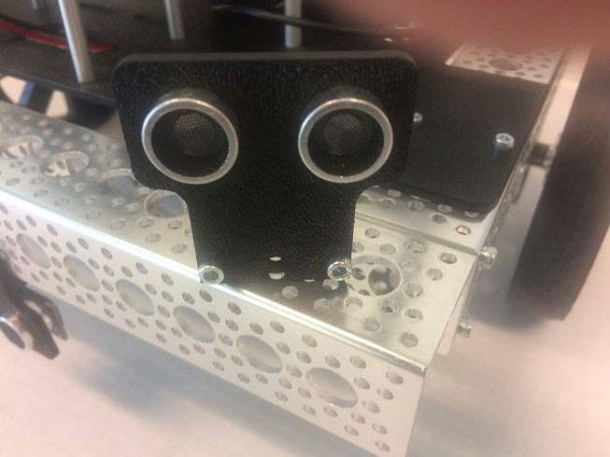Using the dual mount A brackets, 6-32 1/2" screws, and sonar mounts, mount the left, right, and center sonar sensors as shown.

# Mount the Camera

1. Mount the camera to the front of the chassis using zip ties.

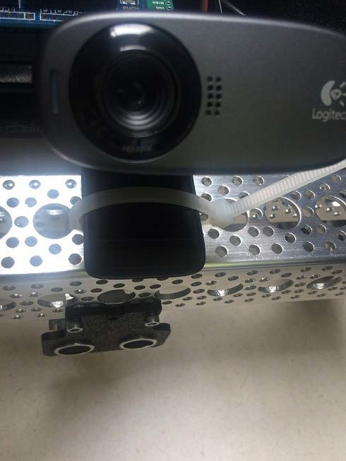

1. Connect the USB cable of the camera to the USB hub.

# Last Steps: Ardunio wiring

See the Arduino wiring diagram for the final wiring placement.